Method Validation/Verification Report
Test Method: Determination of Volatile Matter
Standard Method: ISO 589
Matrix: Coal samples
Laboratory: AzureSky
Analyst: Sifiso Nyambi and Tshepo Maponya
Date: 11/04/2026 to 15/04/2026

1. Objective and Scope
Objective: To verify that the laboratory can successfully implement ISO 589 (Method B-air drying) and achieve the precision and bias requirements specified in the standard.
Scope: Applies to Total Moisture analysis in different types of coal e.g., bituminous and anthracite; using drying oven and top pan.

2. References
- ISO 589: Hard coal and coke — Determination of Total Moisture
- ISO/IEC 17025:2017 Clause 7.2.
- Laboratory Quality Manual

3.Equipment and traceability

Equipment Name | Company ID | Calibration due date | UoM (from certificate)
Crusher (-25mm) | AS8284 | NA | NA
Crusher (-10mm) | AS8809 | NA | NA
Crusher (-3mm) | AS5935 | NA | NA
Drying Oven (107 ºC) | AS8501 (NKOT M02.5 A+B) | December 2026 | ± 1 ºC
Riffler splitter | NA | NA | NA
Cone and quarter | NA | NA | NA
Pans | (Numbered on pans) | NA | NA
Top Pan | AS00A31 | March 2027 | ± 0.3 g

4. Reagents and Materials
- Certified Reference Material (CRMs): PT samples from the month of March 2026 were used, these were provided by Coal Concept. Given that TM does not have a CRM, the CAB has used the “consensus mean” from the PT report as the assigned value.
- Gases: Drying in air (oven capable of maintaining 105-110 ºC for 3-5 hours)

5. Personnel Competency

The following personnel have been trained on SOP AS015IW and are deemed competent to perform the verification.
- Sifiso Nyambi
- Tshepo Maponya

6. Performance Characteristics
6.1. Accuracy
CRMs for TM are a headache because coal is physically and chemically unstable regarding moisture. As soon as the “bottle” is open, the moisture content begins to change based on the CAB’s humidity. This makes the “true value” a moving target.
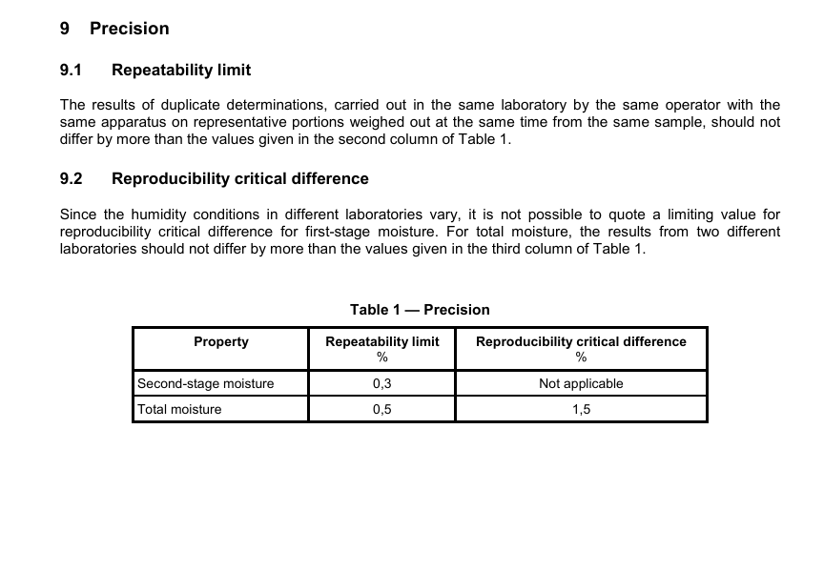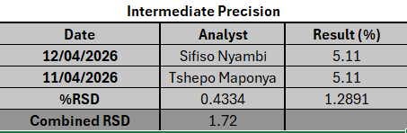
Since a CRM is not a viable option, the lab has opted to using the precision data in Table 1 (above) of the ISO 589 to prove its competence. Below is a detailed description of how:
- Repeatability limit (0.5%)
This is the primary tool for internal verification. It tells us how much “noise” is allowed between two tests of the same sample done by the same person on the same equipment.
Criteria for acceptance: Every single pair’s difference must be less than or equal to 0.5%
The table below shows the analysis conducted by the CAB for TM verification.
Run # (LIMS no) | Analyst | Result A (%) | Result B (%) | Difference | Run # (LIMS no) | Analyst | Result A (%) | Result B (%) | Difference
11328 | Sifiso Nyambi | 5.1 | 5.1 | 0.03 | 11333 | Tshepo Maponya | 5.1 | 5.1 | 0.0
11329 | Sifiso Nyambi | 5.2 | 5.1 | 0.06 | 11334 | Tshepo Maponya | 5.0 | 5.2 | 0.2
11330 | Sifiso Nyambi | 5.1 | 5.1 | 0.02 | 11335 | Tshepo Maponya | 5.1 | 5.1 | 0.0
11331 | Sifiso Nyambi | 5.1 | 5.1 | 0.02 | 11336 | Tshepo Maponya | 5.0 | 5.2 | 0.2
11332 | Sifiso Nyambi | 5.1 | 5.1 | 0 | 11337 | Tshepo Maponya | 5.1 | 5.1 | 0.0
Mean |  | 5.11 | 0.02 |  | Mean |  | 5.11 | 0.07
Verification Goal: If ≥95% of the duplicates fall within 0.5% limit, then the CAB has successfully verified it’s repeatability objectives.
Conclusion: Since all the duplicates from the above table are within the 0.5% limit. The lab has successfully verified its repeatability criteria.
- Reproducibility (≤1.5%)
Since there is not a CRM to check for bias, the lab shall use inter-laboratory comparison.
Criteria: The difference between CABs result and the mean of the PT must be <1.5%.
- Using report 69 issued on date 31th October 2025 by Coal Concept. The CAB’s lab ID 143e.
- CABs TM and z-score, 8.0% and 0.12; respectively.
- Average: 7.9
- Difference = 8.0 – 7.9 = 0.1%
Conclusion: Since 0.1% < 1.5%. Reproducibility has been proven.
- Using report 71 issued on date 28th February 2026 by Coal Concept. The CAB’s lab ID 143e.
- CABs TM and z-score, 4.5% and -1.13; respectively.
- Average: 5.1
- Difference = 5.1 – 4.5 = 0.6%
Conclusion: Since 0.6% < 1.5%. Reproducibility has been proven.
- Accuracy without CRM
Since CRM is unavailable, ISO 17025 Clause 7.7.1 offers several “workarounds” to ensure validity of results.
- Proficiency Testing: The CAB’s z-score has consistently been between -1 and 1, which proves the CABs ability to produce accurate TM results.
- The replicate testing also proves consistency in results, if the above data is considered- all the differences in replicate results were <0.5%

7. Measurement Uncertainty (Mu)
Budget Uncertainty table below:

Uncertainty Component | Source of Data | Type A or B | Distribution | Sensitivity Coefficient | Standard Uncertainty | (Standard Uncertainty) ^2
Repeatability | Lab Validation data | A | Normal | 1 | 0.0003 | 0.00000009
Balance Calibration | Calibration Cert | B | Normal/Rectangular | 1 | 0.0003 | 0.00000009
Balance resolution | Manufacturer spec | B | Rectangular | 1 | 2.9E-05 | 8.33333E-10
Oven | Validation/Calibration | B | Rectangular | 1 | 0.002697898 | 7.27866E-06
Weight of sample | Measurement process | B | Rectangular | 1 | 0.001003 | 1.00601E-06
Sample preparation | Lab Validation data | A | Normal | 1 | 0.0052 | 0.00002704
Combined Uncertainty | 0.005958649
Expanded uncertainty | 0.011917298

- Expanded Uncertainty (U): ± () %
- Coverage Factor (k): 2 (at 95% Cl)
Other factors Influencing Uncertainty for TM
- Sample homogeneity
- Loss of moisture during prep
- Oven Temperature gradients
- Sample Mass
- Airflow

7. Deviations from Standard method
- None

8. Conclusion and Statement of Fitness for purpose.
Based on the data presented in this report, the laboratory has demonstrated that it meets the performance requirements of ISO 589. The method is considered fit for purpose for the analysis of Total Moisture in coal within the defined scope.

9. Approval

Date: 16-04-2026
Reviewed by: Tshepo Maponya (Laboratory Supervisor)
Authorised by: Nonhlanhla Msibi (Operations Manager)

